|  |
| --- |
| Wegmans Devam Patel |
| Image result for wegmans |

|  |  |
| --- | --- |
| 12/13/2018 | Wegmans Database Problem |

|  |
| --- |
| There was a problem in Wegmans database to save the Post Transaction for customers and show on hand quantity. |

# Subset 1

Name: Devam Patel

Company: Wegmans

Location (Headquarter): Rochester, NY

Type of store: Grocery

Website: <https://www.wegmans.com>

**Information About the Company**:

Wegmans is a regional supermarket chain with 97 stores: 46 in New York, 17 in Pennsylvania, 9 in New Jersey, 11 in Virginia, 8 in Maryland, and 6 in Massachusetts. It is one of the largest private companies in the U.S. The company has

* 48,000 employees
* Annual sales in 2017 of $8.7 billion
* 31st on the 2017 *Supermarket News* list of the Top 75 Supermarkets based on sales volume

Wegmans is a family-owned company, founded in 1916, headquartered in Rochester, NY. Danny Wegman is chairman; Colleen Wegman, his daughter, is president and CEO. Danny’s daughter Nicole Wegman is sr. vice president. Robert Wegman, Danny’s father, was chairman until his death in April 2006.

**Wegmans Founders**

Brothers Walter and John Wegman (Robert Wegman’s father and uncle) learned the food business by working in their parents’ store in Rochester. John peddled fresh produce from a pushcart, and in 1916, he opened the Rochester Fruit & Vegetable Company, which marks the beginning of Wegmans Food Markets. Walter joined him a year later. Robert Wegman assumed leadership of the company in 1950, guiding it until his death in 2006.

***Database Problem***

The company database problem is storing the selling item. One employee from each department must count the product every day and see how many they sell on that day, so they can adjust the cycle count on daily basis and employee has an idea about how many to order. That’s how they don’t get product on daily basis. This problem cause Wegmans and customer. Wegmans gets affect by ordering more, if they order more that pay more and end up with not selling that product, so they must throw out the products that cause the company by money. Customer get effects by dissatisfied when stock runs out of stock. I want to solve this problem by getting the product name and how many they sell by end of the day. If they have to order 10 boxes of butter for Saturday and already, they have around 3 boxes of butter in backstock and 2 boxes of butter they sold on Friday and 2 boxes of butter on shelf, 5 boxes of butter on hands manager of the department need to order just 5 more to have enough butter for customers. I’m thinking to solve this problem by making a new raw for the each product in database, so when it’s time to give order for the next day then manager can look that up on the data table and will be able to figure out the amounts of products need for the next day, also I want to make a new row that displays the amount of product in hands by that way employee doesn’t have to do cycle count every day. When employee is giving order, they can just look at the table and have an idea of what amount of product to order.

SUBSET 2

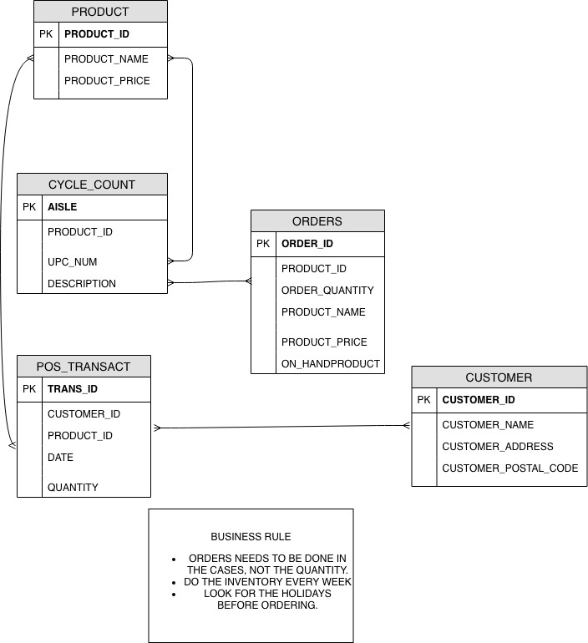

SUBSET 3

5 Tables

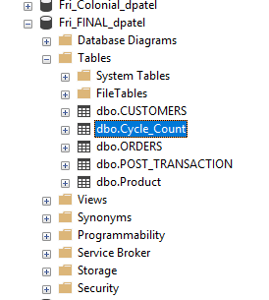

Customers Table

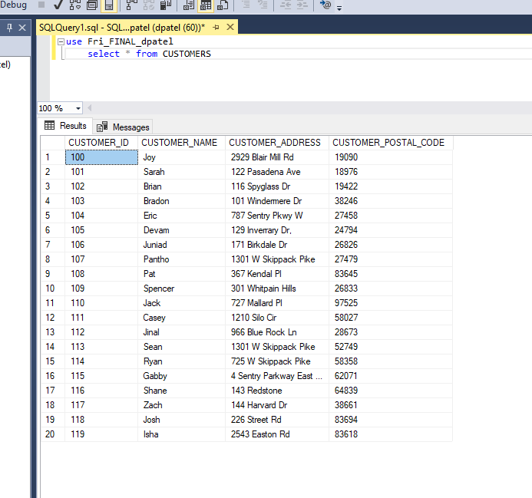

**Cycle_Count Table**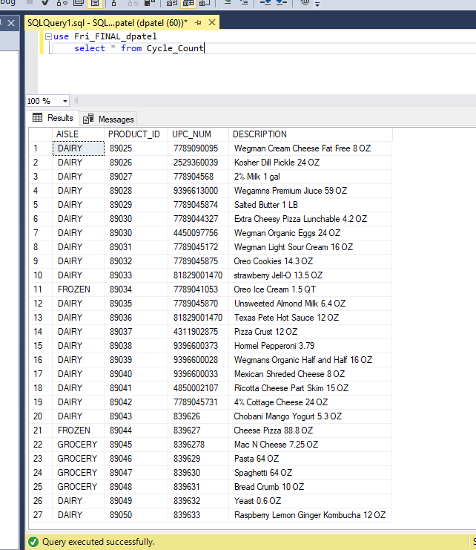

**Orders Table**

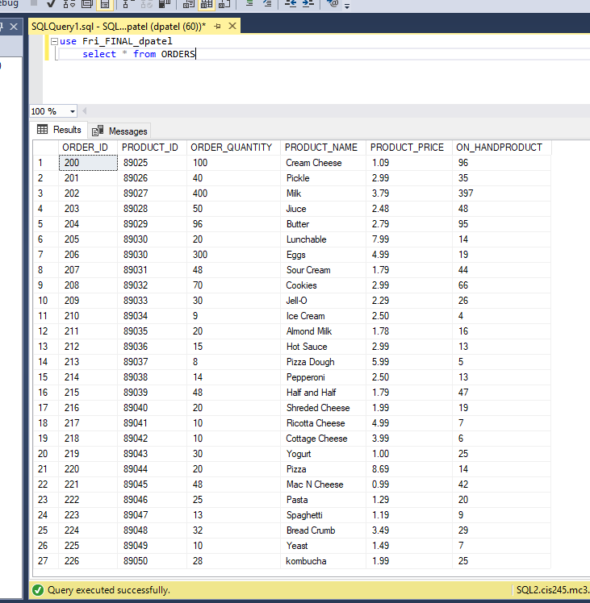

**POST_TRANSACTION Table**

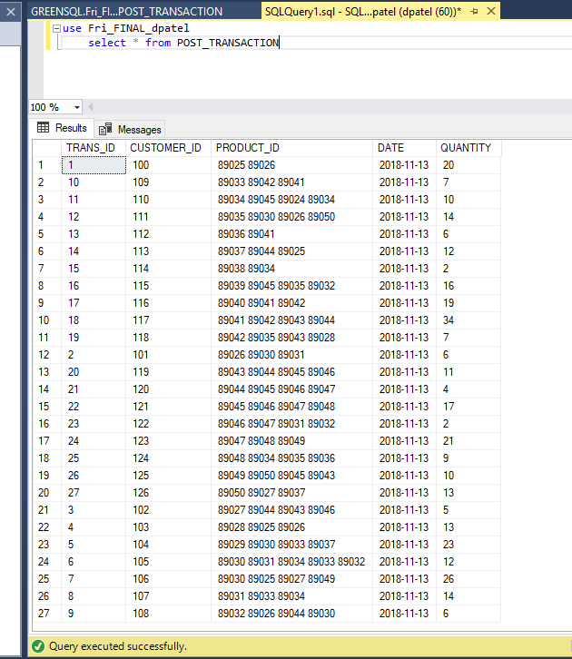

Product Table

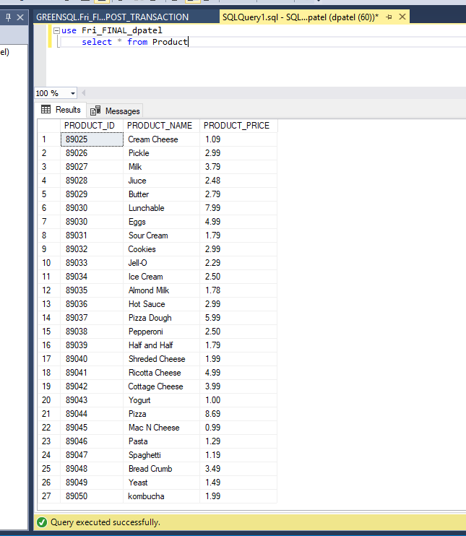

Subset4

My created database help will employee of the company when they will order stuff for the next day. I added new column called on hand product which will tell that how many products does the department has on hands which mean in backstock and on the shelf. In the process of doing order for the next day employee from the department had to count the product or had to assume that how much they going to need for the next day. If they assume the on-hand products and order it that will be lost for the company and also for the customers by not providing enough product to the customers and by getting more things in order company had to pay extra and some of the products has less life on shelf and the department end up with throwing the products out which is waste of food and money both. After adding the on-hand column in the order table employee will be able to do order easily. In the product table the I added one more column called ON_HAND_PRODUCT which tells the employee that how many products they have in available for sale at this moment, so now the order table looks like this with this type of column (PRODUCT_ID) (ORDER_QUANTITY) (PRODUCT_NAME) (PRODUCT_PRICE) and (ON_HAND_PRODUCT). Below attached picture shows the code that will help the employees to order easily. In the table there is column called ON_HANDPRODUCT that shows the available amount of product for sale now. That gives an idea to the employee to order the quantity for the next day. As soon as customer buys the product the ON_HANDPRODUCT number decrease, example if customer buy 1 quantity of PRODUCT_ID 89025 then ON_HANDPRODUCT will decrease by 1 and will be 99. ORDER_QUANTITY column shows the actual quantity to order to be ready for the next day.

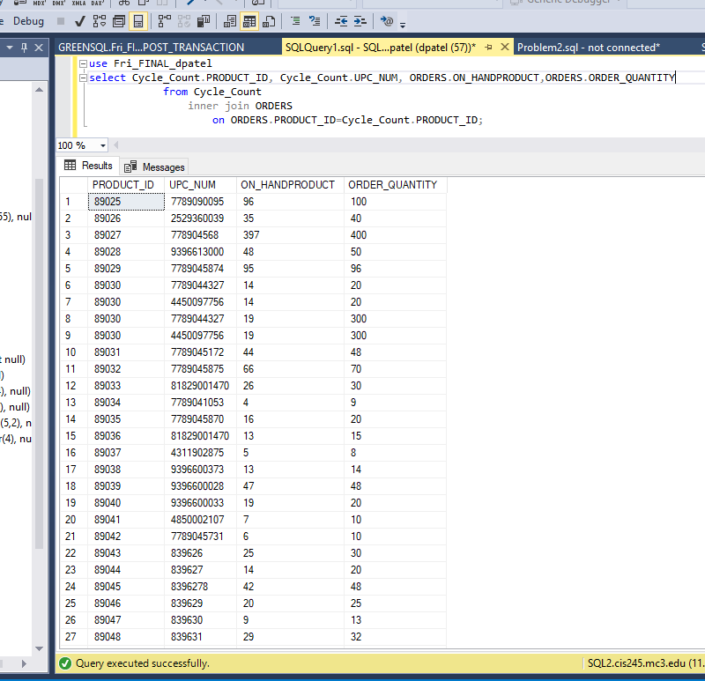

Second database problem for the company was that storing the PRODUCT_IDs that customers bought. If customer lose their receipt they can’t return the stuff and they lose money. By that Wegmans was losing the customers. I added new table in the database called POS_TRANSACT. POS_TRANSACT table has 5 column which is (TRANS_ID), (CUSTOMER_ID), (PRODUCT_ID), (DATE) and quantity. TRANS_ID will show the transaction number, CUSTOMER_ID is a number that every customer gets when they shop the products, PRODUCT_ID shows that how many product customers bought. DATE shows the date of the transaction and QUANTITY shows the total amount of quantity customer bought. Now if customer want to return the product and lose the receipt still customer can return the product. Now Wegmans database stores the data now. Below attached image is the sample database I’ve created.

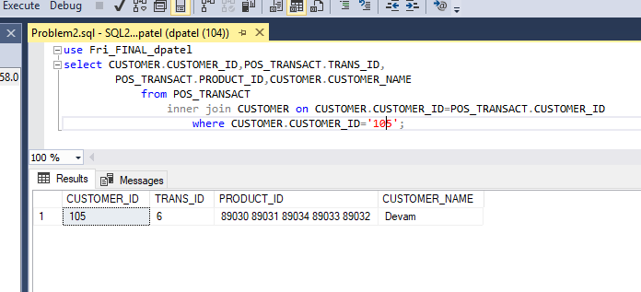

This code will give result in CUSTOMER_ID, TRANS_ID, PRODUCT_ID and CUSTOMER_ID. CUSTOMER_ID shows the unique id of the customer. PRODUCT_ID shows the product number, by that it’s the proof for the employee and the customer of buying the product.

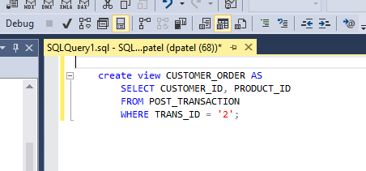

I’ve created create view because I don’t want other people to look at the other customers data. It will restrict other people to look at the data.